LOGISTIC REGRESSION – COEFFICIENTS
In this StatQuest we´ll talk about the coefficients that are the result of any logistic regression; we´ll talk about how they are determined and interpreted…
… we´ll talk about the coefficients in the context of using a CONTINUOS variable like weight to predict obesity … and we´ll talk about the coefficients in the context of testing if a DISCRETE variable like ´whether a gene mutated´ is related to obesity.
QUICK REVIEW
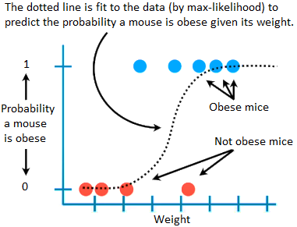
GENERALIZED LINEAR MODELS
Logistic regression is a specific type of generalized linear model (GLM) … GLMs are generalization of the concepts and abilities of regular/general linear models, which we´ve already covered in the series ´linear models´.

CONTINUOS PREDICTOR VARIABLE
We´ll start by talking about logistic regression when we use a continuous variable (like weight) to predict obesity … this type of logistic regression is closely related to linear regression (a type of linear model)
With linear regression, the values on the y-axis can, in theory, be any number …
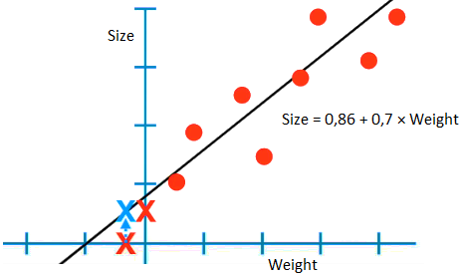
… the fact that we are not limiting the equation domain and range makes it easier to solve (we are mentioning this because it has a big effect in how logistic regression in done) …
… Unfortunately, with logistic regression, the y-axis is confined to probability values between 0 and 1 … to solve this problem, the y-axis is transformed from the ´probability of obesity´ to the ´log odds of obesity´ … so, just like the y-axis in linear regression, it can go from -infinity to +infinity.
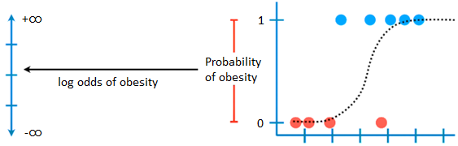
Okey, now let´s transform this y-axis from a probability scale to a log odds scale; we do this with the LOGIT FUNCTION …
$$\log\left(odds\right)=\log\left(\frac{p}{1-p}\right)$$
$p$, in this case, is the probability of a mouse being obese, and corresponds to a value on the old y-axis between 0 and 1.
The mid-point on the old y-axis corresponds to $p=0,5$, and when we plug that value into the logit formula, we get 0, the centre of the new y-axis:
$$p=0,5→\log\left(odds\right)=\log\left(1\right)=0$$
If we plug $p$ into the logit formula, we get $\log\left(\frac{p}{1-p}\right)$ on the new y-axis:
$$p=0,731→\log\left(odds\right)=\log\left(2,717\right)=1$$
$$p=0,88→\log\left(odds\right)=\log\left(7,33\right)=2$$
$$p=0,95→\log\left(odds\right)=\log\left(19\right)=3$$
Lastly, if we plug $p=1$ into the logit formula, we get … well technically, we can´t divide by 0, however … if we apply log properties this whole thing turns out to be positive infinity:
$$p=1→\log\left(odds\right)=\log\left(\frac{1}{0}\right)=\underset{0}{\underbrace{\log\left(1\right)}}-\underset{-∞}{\underbrace{\log\left(0\right)}}=∞$$
This means the original samples that were labeled ´obese´ are at positive infinity in the new y-axis.
As a result, the original y-axis, from 0,5 to 1, is stretched out from 0 to positive infinity on the new y-axis. Similarly, 0,5 to 0 on the old y-axis is stretched out from 0 to minus infinity on the new y-axis. Ultimately, we ended up with log odds of obesity on the new y-axis … and the new y-axis transforms the squiggly line into a straight line.
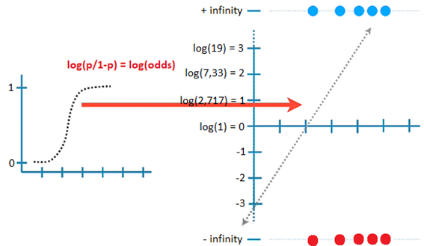
The important thing to know is that even though the graph with the squiggly line is what we associate with logistic regression … the coefficients are presented in terms of the log(odds) graph.
In the following StatQuest we´ll talk more about how this straight line is fit to the data, but for now this is the best fit … just like with linear regression, the best fitting line has y-axis intercept and a slope:
$$log\left(odds\right)=-3,48+1,83×weight$$
The first coefficient is the y-axis INTERCEPT when weight = 0 … it means that if a mouse weight 0, the log odds are -3,4 (in other words, if the mouse doesn´t weight anything, the odds are against it being obese ! Duh !)
Here´s the standard error for the estimated intercept …
Coefficients
 | Estimate | Std. Error | Z value | Pr(>|z|)
(Intercept) | -3,476 | 2,364 | -1,471 | 0,1414

… and the z-value is the estimated intercept divided by the standard error, in other words, it´s the number of standard deviations the estimated intercept is away from 0 on a standard normal curve … this is WALD´s TEST … since the estimate is less than 2 standard deviations away from 0, we know it is not statistically significant … and this is confirmed by the large p-value (the area under the curve that is further than 1,471 sd away from 0.
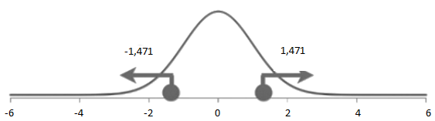
The second coefficient is the SLOPE … it means that for every one unit of weight gained, the log odds of obesity increases by 1,825.
Here´s the standard error for the estimated slope …
Coefficients
 | Estimate | Std. Error | Z value | Pr(>|z|)
weight | 1,85 | 1,088 | 1,678 | 0,0934

… and again, the estimate is less than 2 sd away from 0, so it is not statistically significant, and this is confirmed by the large p-value (this is no surprise with such a small sample size).
DISCRETE PREDICTOR VARIABLE
Now let´s talk about logistic regression coefficients in the context of testing if a discrete variable like ´whether a mouse has a mutated gene or not´ is related to obesity … this type of logistic regression is very similar to how a t-test is done using linear models.
This is our data … we have mice with normal gene vs mice with mutated gene, at the same time some of those mice are obese and some are not …
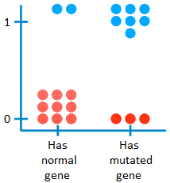
The first thing we do is transform the y-axis from the probability of being obese to the log odds of obesity … but now we fit two lines to the data…
… for the FIRST LINE, we take the just normal gene data and use it to calculate the log odds of obesity:
$$p=\frac{2}{11}=0,1818→odds=\frac{p}{1-p}=0,2222$$
$$\log\left(odds\right)=\log\left(\frac{2}{9}\right)=\log\left(0,22\right)=-1,5$$
Thus, $\log\left(odds\right)=-1,5$ represents the log odds of obesity for mice with normal gene. Let´s call this $log(odds gene_{normal})$.
… for the SECOND LINE we do the same but with the mutated gene data:
$$p=\frac{7}{10}→odds=\frac{p}{1-p}=\frac{7}{3}$$
$$\log\left(odds\right)=\log\left(\frac{7}{3}\right)=\log\left(2,33\right)=0,85$$
Thus, $\log\left(odds\right)=0,85$ represents the log odds of obesity for mice with mutated gene. Let´s call this $log(odds gene_{mutated})$.
These two lines come together to form the coefficients in this equation:
$$\log\left(odds\right)=\begin{aligned}\log\left(odds gene_{normal}\right)×B_{1} \\ +\left[\log\left(odds gene_{mutated}\right)-\log\left(odds gene_{normal}\right)\right]×B_{2}\end{aligned}$$
$$\log\left(a\right)-\log\left(b\right)=\log\left(\frac{a}{b}\right)$$
$$\log\left(odds\right)=\log\left(odds gene_{normal}\right)×B_{1}+\log\left(\frac{odds gene_{mutated}}{odds gene_{normal}}\right)×B_{2}$$
By using log-properties we converted the second term into a log of the odds ratio. This tells us, on a log scale, how much having the mutated gene increases (or decreases) the odds of a mouse being obese.
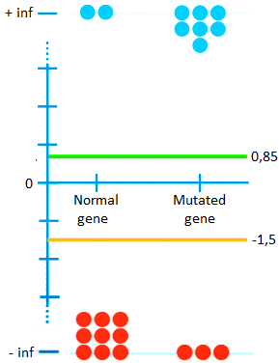
Okey, now that we have the equation, let´s substitute in the numbers and do the math … and that gives us these coefficients…
$$\log\left(odds\right)=log\left(2/9\right)×B_{1}+\log\left(\frac{7/3}{2/9}\right)×B_{2}$$
$$\log\left(odds\right)=-1,5×B_{1}+2,35×B_{2}$$
NOTE: $B_{1}$ and $B_{2}$ are the first and second columns of the design matrix $X=\left[\begin{aligned}1 \\ ⋮ \\ 1 \\ 1\end{aligned}\begin{aligned} \\ \\ \\ \end{aligned}\begin{aligned}0 \\ ⋮ \\ 1 \\ 1\end{aligned}\right]$.
Here is the output of doing logistic regression for this dataset in R:
Coefficients
 | Estimate | Std. Error | Z value | Pr(>|z|)
(Intercept) | -1,504 | 0,7817 | -1,924 | 0,0544
geneMutant | 2,3514 | 1,0427 | 2,255 | 0,0241

The ´intercept´ is the log of the odds for gene normal. And the ´geneMutant´ term is the log of the odds ratio that tells you, on a log scale, how much having the mutated gene increases (or decreases) the odds of being obese.
We see the standard error for the estimated coefficients … and we also see the ´z-values´ (aka Wald Test) that tell you how many sd the estimated coefficients are away from 0 on a standard normal curve …
… for the intercept, |-1,9| < 2, thus it is not significantly different from 0 (and this is confirmed with p-value > 0,05)
… for the geneMutant term, 2,255 > 2, suggesting the estimated coefficient is statistically significant ! (and this is confirmed by p-value < 0,05)
CONCLUSION
In short, in terms of the coefficients, logistic regression is the exact same thing as good old linear models (liner regression and t-test) except the coefficients are in terms of the log(odds).
This means that all the fancy things we can do with linear models (like multiple regression and ANOVA) can be done using logistic regression. All we have to remember is that the scale for the coefficients is the log(odds).

